Introduction Assignment

In this assignment you get introduced to Amazon AWS Service. The tasks performed in this assignment is listed below.
- Create an AWS account with your @uncc email (if you don’t already have one)
- Set up your own storage space on the Cloud and upload a csv file.
- Set up a virtual machine on the cloud, install Python and tools for analysis
- Run a Jupyter Notebook on the instance and submit the output

To complete this assignment, you must print the output of the dbsa6190_intro.ipynb notebook to PDF, and upload it to canvas.

AWS Educate
In this step you’re going to create or log into your Amazon Web Services account (AWS account). This account will be used to create and use cloud resources on Amazon’s platform. By using your UNCC email address, you will automatically get access to cloud resources.

Account Creation Instructions:
- Go to https://aws.amazon.com/education/awseducate/
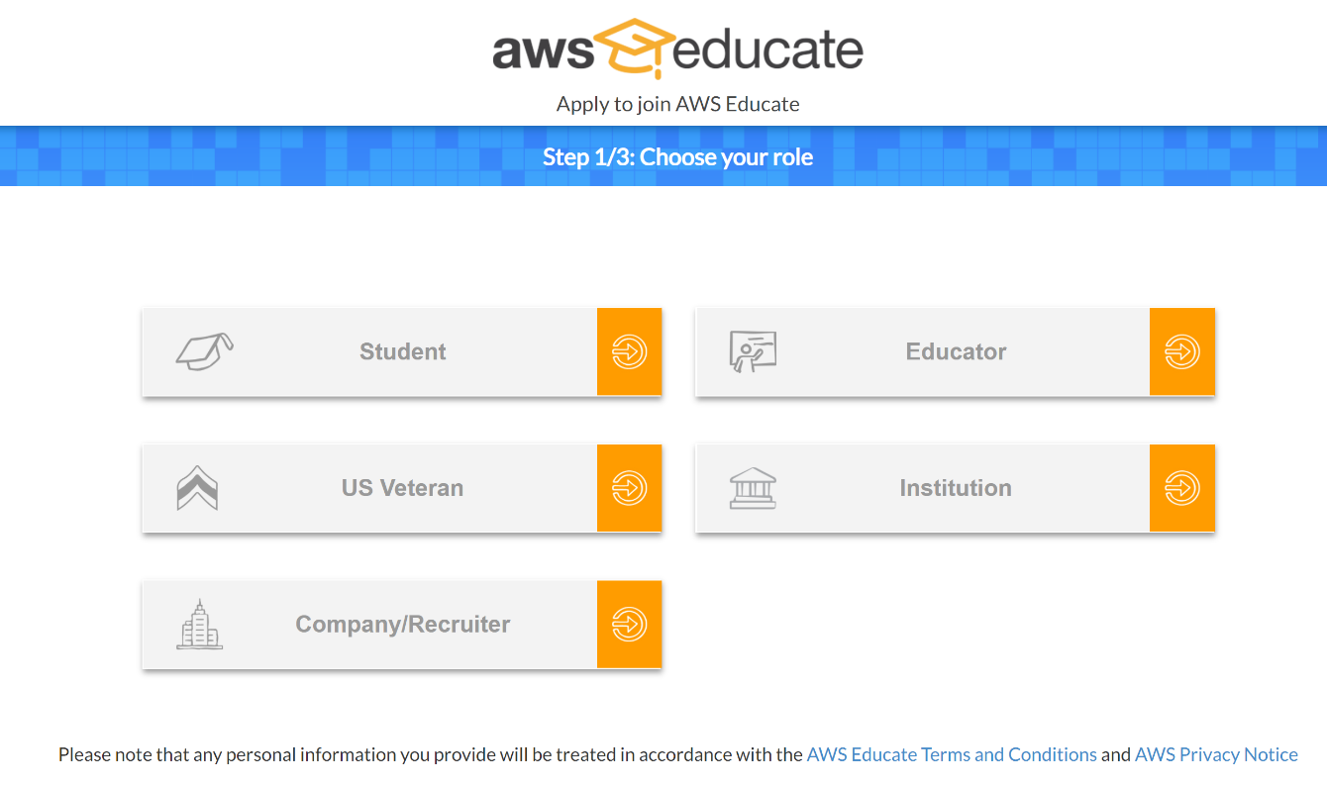
- Click on “Student” and follow the registration process. Use your @uncc.edu email address to take advanteage of free educational credits. If you have already set up an account on AWS, you may see a “My Account” link and already have access to the Management Console. In that case you’re all set.

Sign into AWS:
Navigate to your AWS Management Console (it can be under the “My Account” menu on the upper right hand side).

Setup S3 storage and upload CSV data:
- Download the covid-us-counties.zip file from Canvas and unzip it.
- In the AWS Management Console search for “S3” and select the Scalable Storage Option (refer below image)

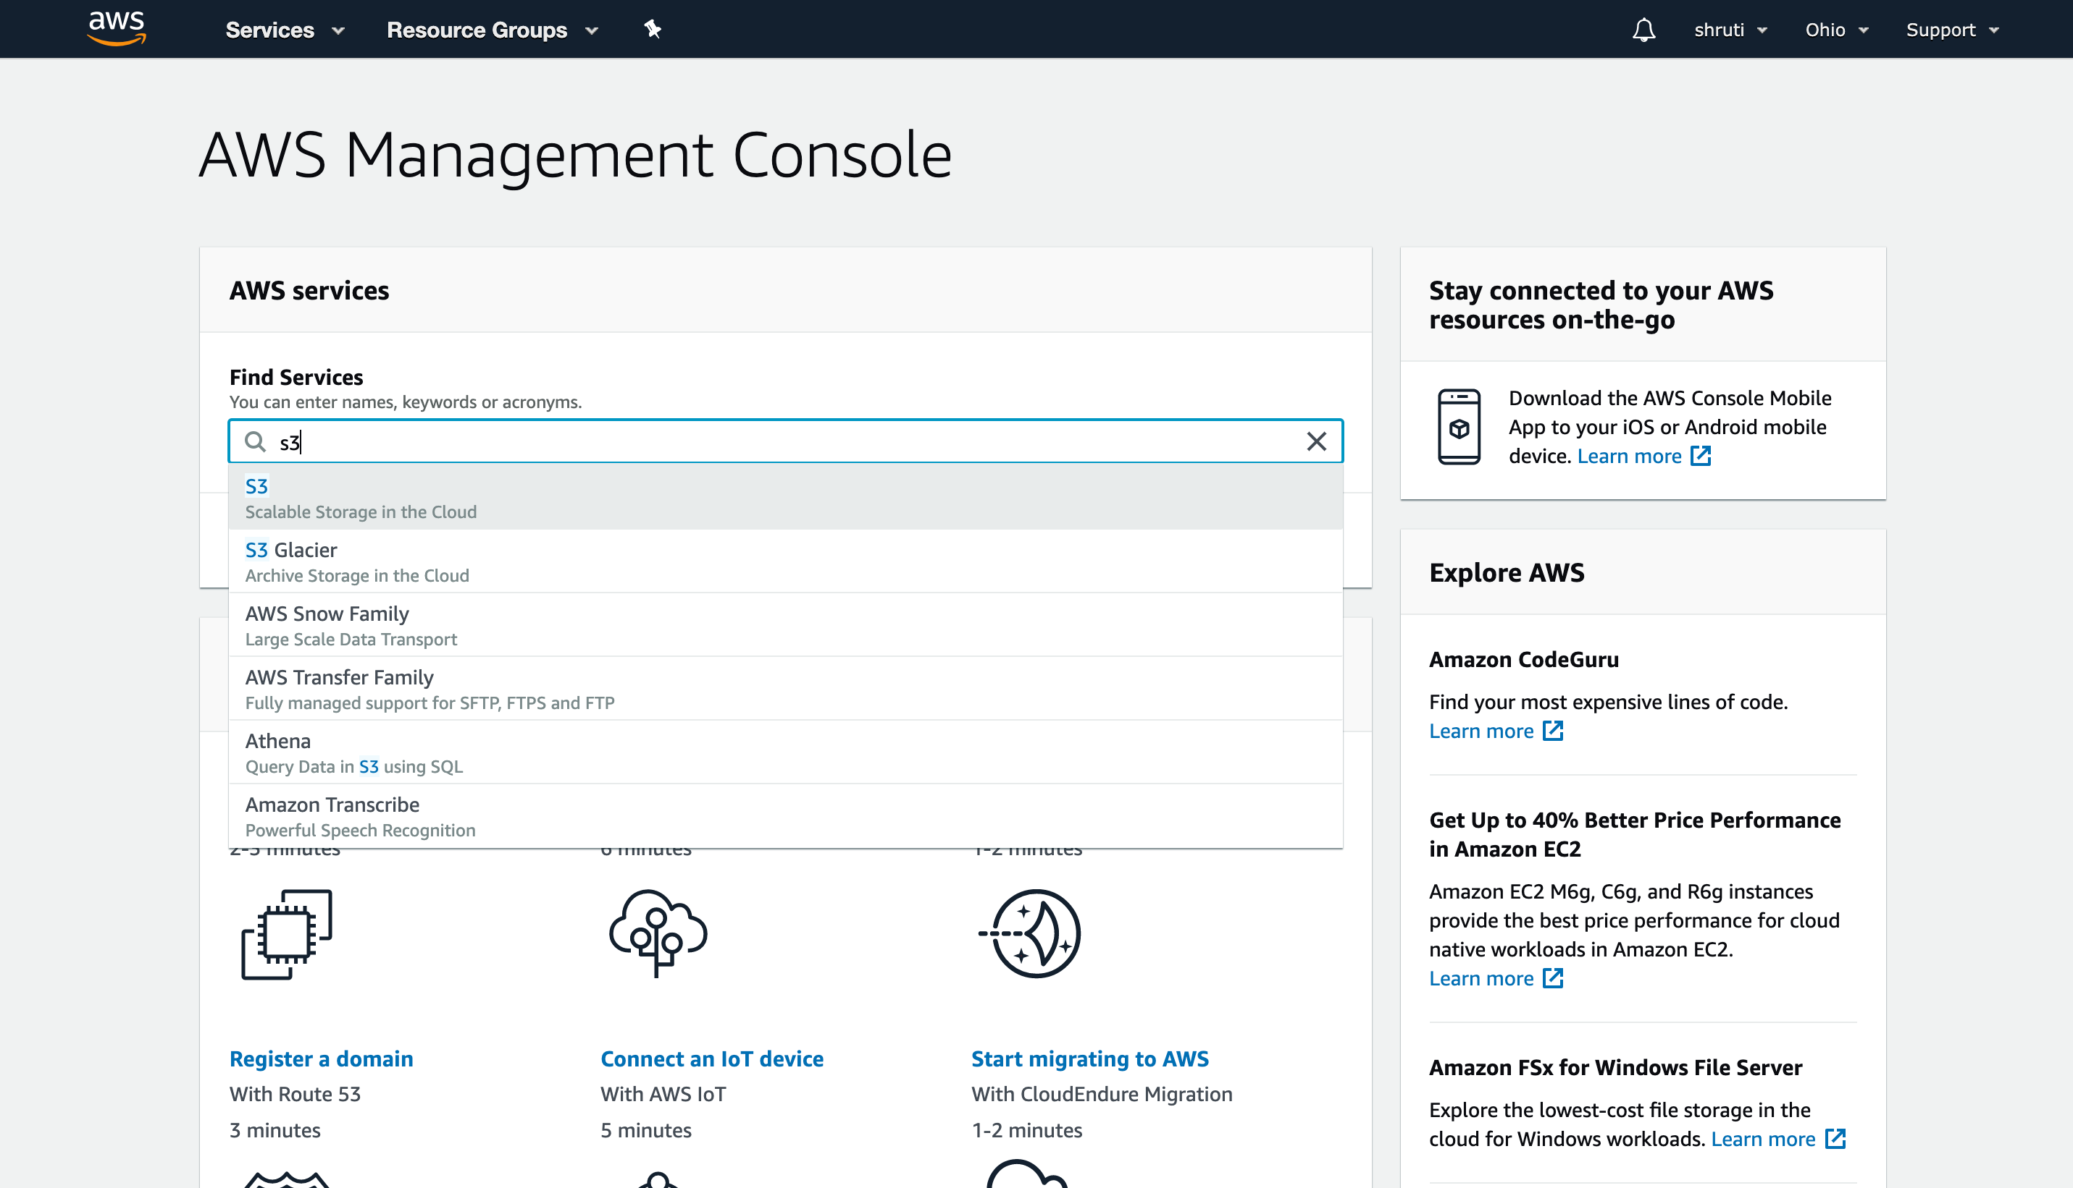

- Click on “Create bucket”
  - Name and Region
    - Bucket Name: give a unique name to bucket. You may want to append your UNC username to make it unique (e.g. “dsba-6190-****”, replace **** with your ID)
    - Region: Select “US East (Ohio)”
  - Configure Option: Do not change anything, hit Next
  - Set Permissions: Do not change anything, hit Next
  - Review and click Create bucket.
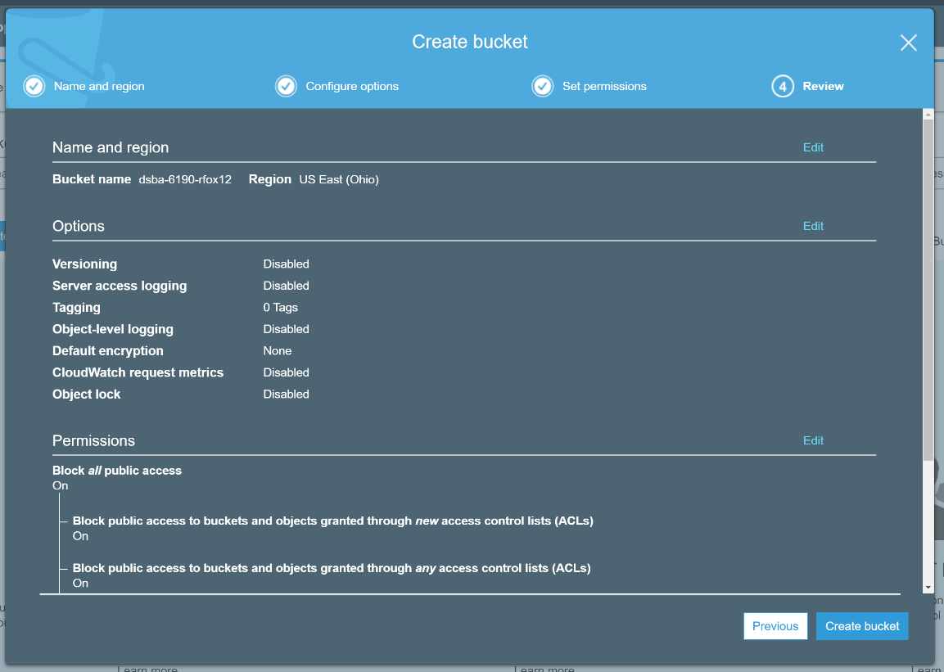

  - Click on your new bucket name then click on Upload --> Add Files --> select the covid-us-counties.csv file from your local machine
  - Set permissions: (default rights for you is Read and Write), hit Next
  - Set Properties: Standard Storage class (default), hit Next
  - Review and Upload
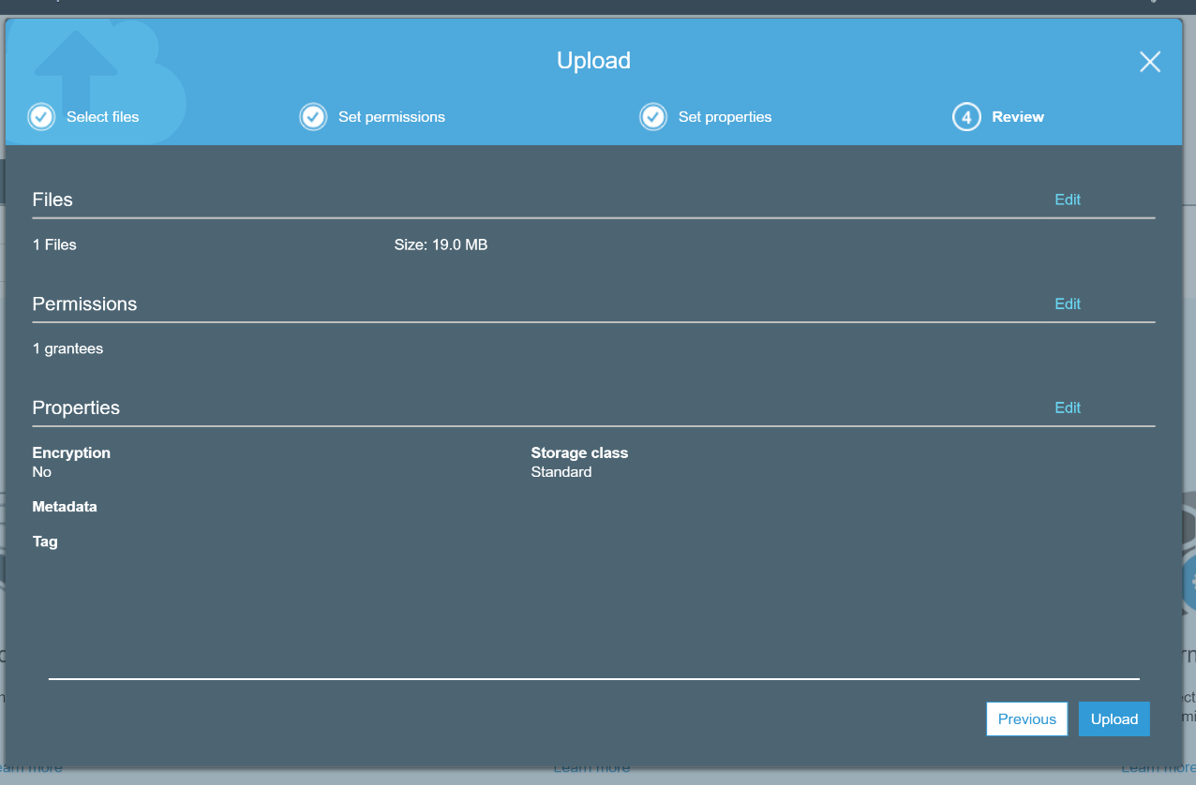

Starting a New Virtual Machine (EC2)
In this step we are going to fire up our very own computer in the cloud. Amazon calls these virtual machines “EC2 instances”. Once we have that machine running we will need to connect to it (using a command line utility). Once connected we will set up a Jupyter Notebook server for hosting our code and doing our own analysis in Python (or R).

- Go back to the AWS Management Console and search for “EC2” and select EC2 Virtual Server in Cloud (refer below image) and click on Launch Instance. You may also find EC2 under the “Services” area and “Compute” sub-area. You may get screens that look different than the screenshots (because AWS is testing a new EC2 console):

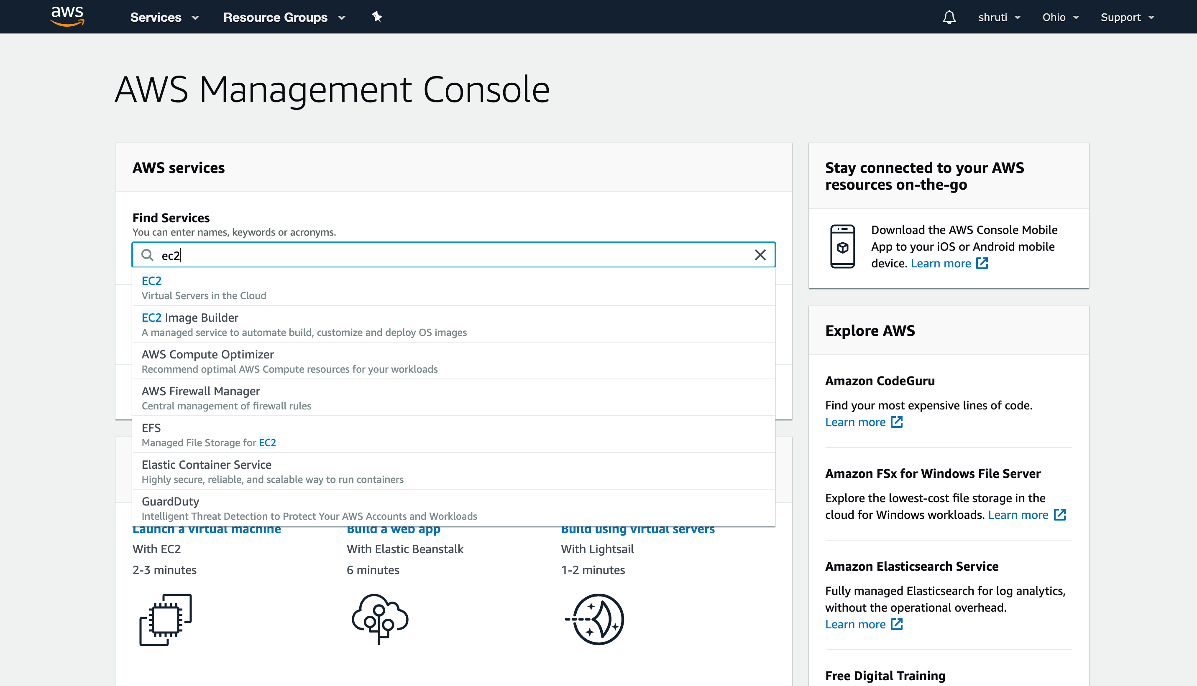

Or

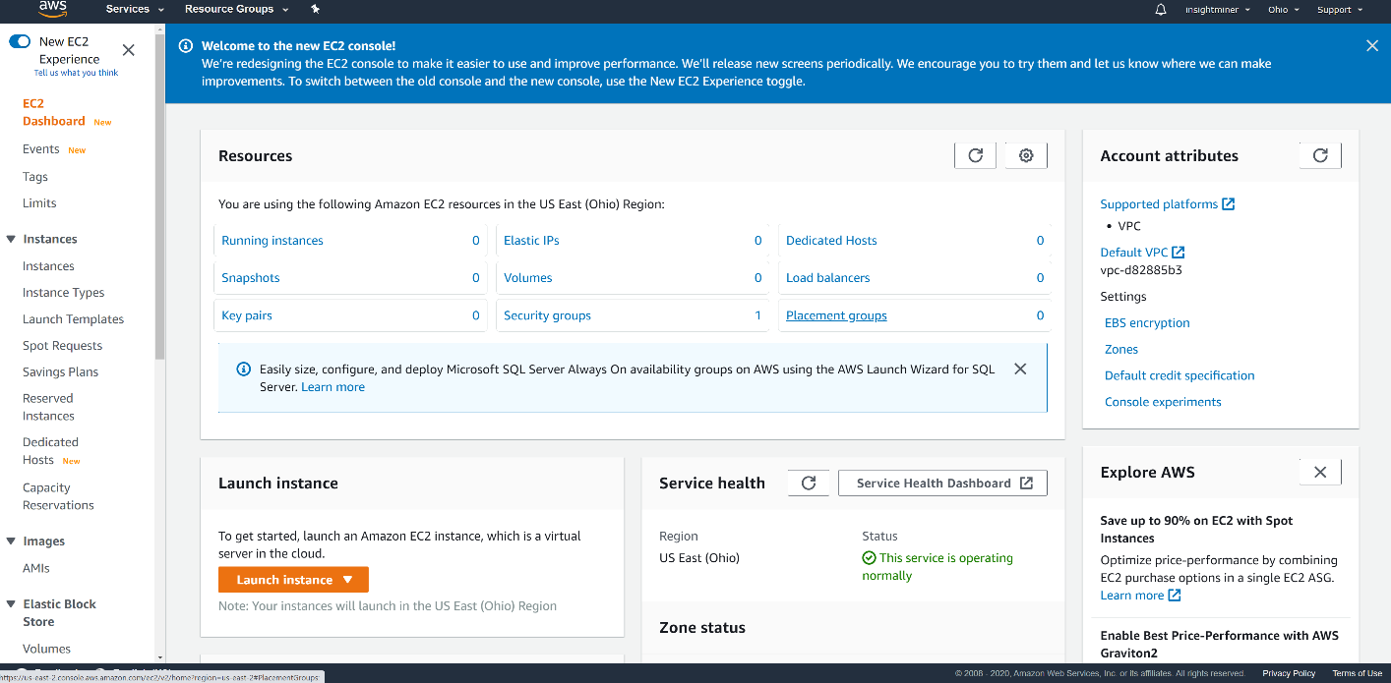

- In any case you want to find the Launch Instance action
- For Amazon Machine Image (AMI) select ‘Ubuntu Server 18.04 LTS (HVM), SSD Volume Type’, use the default “64-bit (x86)”
- For Instance Type choose the General purpose, t2 micro and click ‘Review and Launch’ and click Launch
- 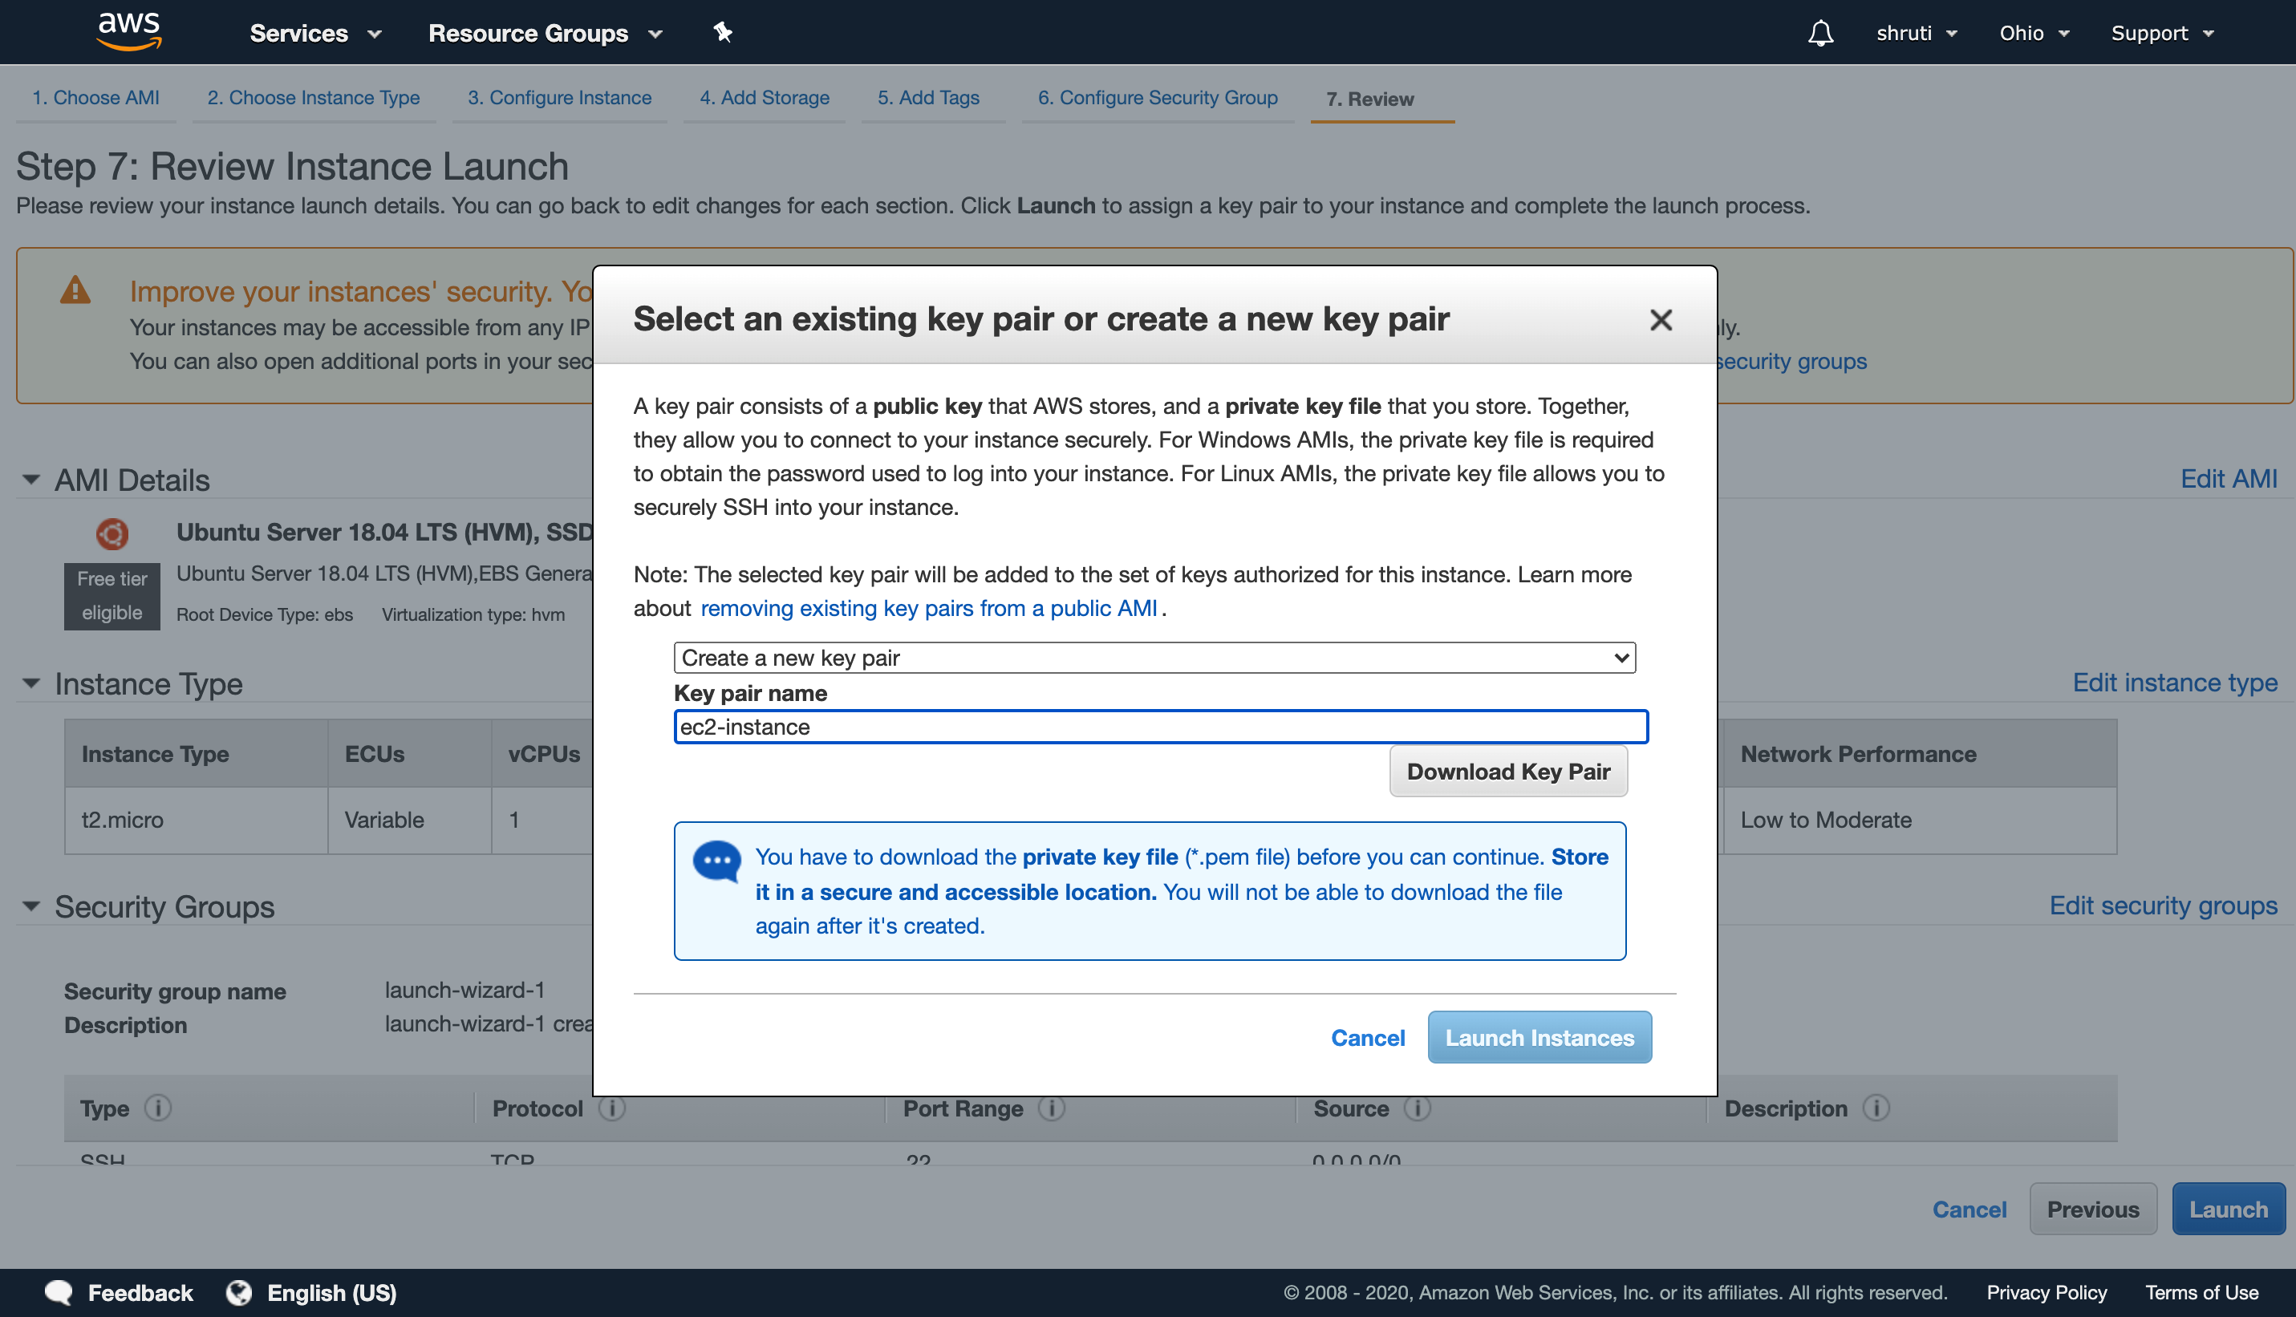Select Create a new key pair and give a name to key pair click ‘Download Key Pair’ and ‘Launch Instances’. You need to download and remember where you put the *.pem file or you will not be able to connect to your cloud instance later.
- You will get a confirmation page that says “Your instances are now launching” select ‘View Instances’ wait until Instance Status changes to ‘running’

Connect to your a New Virtual Machine
We are now going to establish a (command-line) connection to our machine. If you’re on Mac or Linux, you can use SSH. If you’re on Windows, you can use a utility called PuTTY. Instructions below.

To get started, on your AWS Management Console, navigate to EC2. And then find your instance. Start it if needed. If it status is “running” then you’re ready to connect. Select the instance (radio button on the row) and hit Connect.

This Connect screen tells you specifically how you can connect to your cloud instance. Something to keep in mind if you stop and start the same instance: the host name and/or IP address will probably change. This means that connection settings you used in the past may not work in the future.

The Connect screen looks like this:
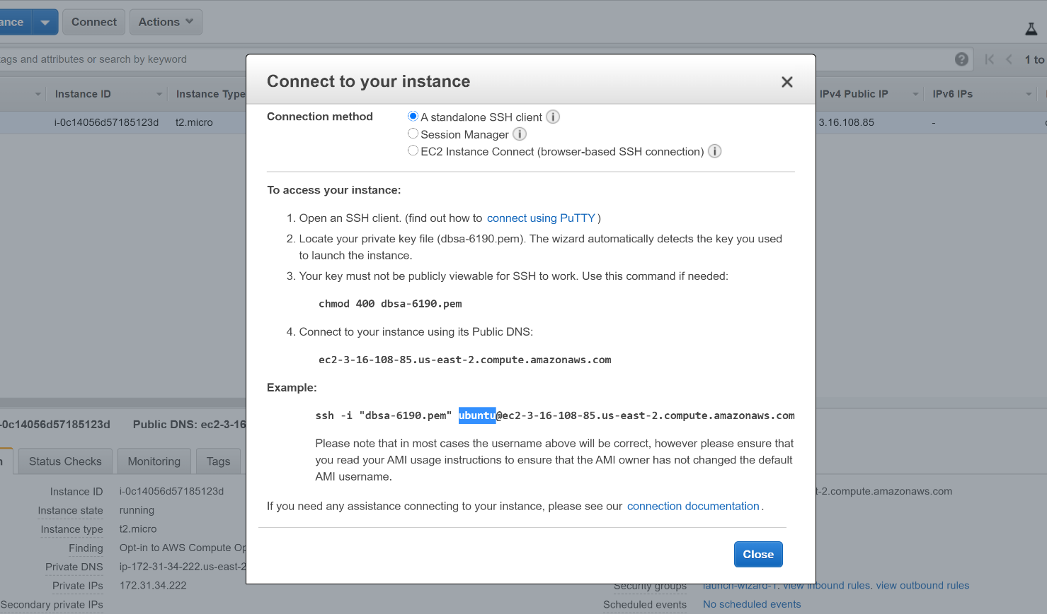

For MAC, follow the on-screen instructions.

For Windows, You can use Powershell’s SSH (recommended) OR use PuTTY. If you want to connect with Putty, click the “connect using PuTTY” link. You may also find the following video helpful: https://www.youtube.com/watch?v=bi7ow5NGC-U

If you see messages, like this, it’s safe to click “Yes”
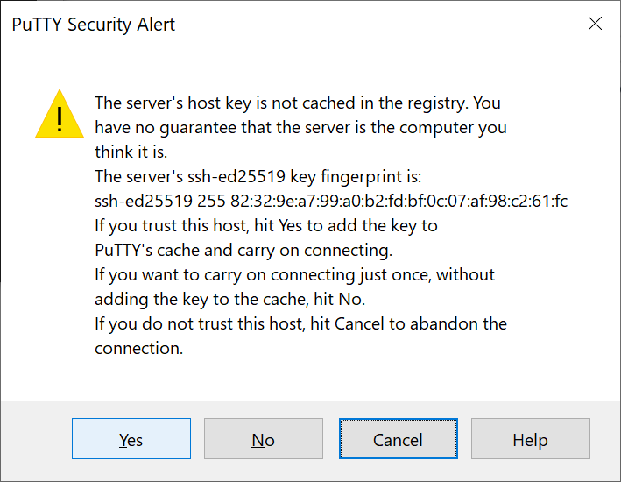

Install Software on our New Virtual Machine
The machine we’ve just created is a “blank slate”. To make it useful, we’ll typically need to install some software. In our case that means some data science tools. But before we do that, we need to install and configure the AWS CLI

First let’s go back to the AWS Management Console. This time we’re going to the “Security Credentials” or “My Security Credentials” page which is often under “My Account” in the upper-right hand corner.
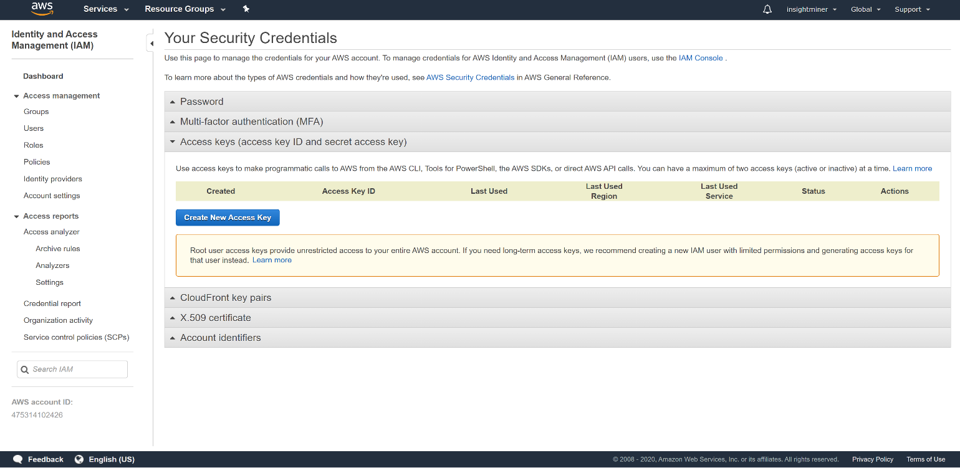

Select “Create New Access Key”

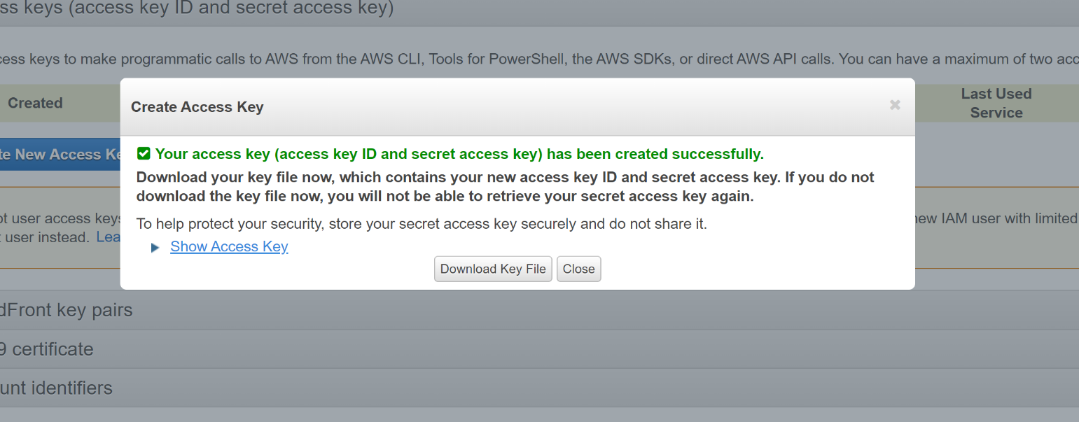

Keep your rootkey.csv secret. These credentials identify you on the AWS platform.

Now go back to the command line interface for your new cloud instance.

- Now we install the AWS CLI using this command: sudo apt install awscli
- After that is done, type: aws configure
  - Use the ID and Key from your rootkey.csv file (credentials you created earlier)
  - For Region type “us-east-2”
  - Leave “output” blank (default)
- To verify that your new machine can access the AWS environment, let’s check and see if we can find our S3 bucket (created earlier): aws s3api list-buckets
Your “Name” will be what you chose when you setup your storage bucket
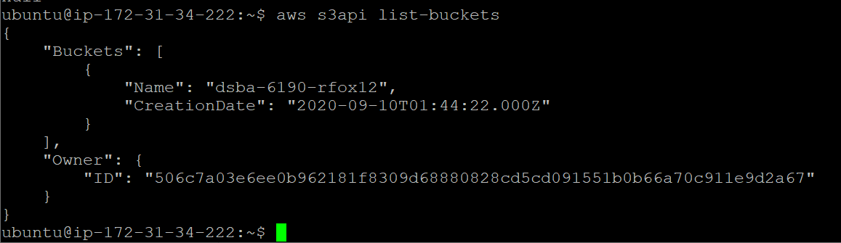
- To install Python type the below link in terminal and once it gets installed type ls to verify
wget https://repo.anaconda.com/archive/Anaconda3-2020.07-Linux-x86_64.sh
- Execute the below command
bash Anaconda3-2020.07-Linux-x86_64.sh
if you get this prompt:
“Do you wish the installer to initialize Anaconda3 by running conda init? [yes|no]”
type yes (if you accidentally hit no you can execute: “./anaconda3/bin/conda init”)
You will probably get a prompt like this:
“==> For changes to take effect, close and re-open your current shell. <==”
You can either disconnect / re-connect your command line connection or simply type:
“source .bashrc” in your command line
- When using Conda, your command prompt should have a new “(base)” prefix
- Type: conda –version
  - Output should be: conda 4.8.3
- Type: python –version
  - Output should be: Python 3.8.3
- We need one more special python library to access our S3 storage, execute: “pip install s3fs”

Congratulations, you’re running Python on a Cloud machine

Setting Up A Jupyter Notebook Environment:
Jupyter will fire up a web server that we can hit with a browser; but special steps are needed to get access. By default, Jupyter will only accept connections from the local machine. This is a security design of the Jupyter authors. Also by default, AWS will not allow you to access your new Cloud instance on port 8888. There are two solutions. Read below.

- For solution 1, On our cloud instance command line….
- Run command: jupyter notebook --generate-config
  - You should see:
“Writing default config to: /home/ubuntu/.jupyter/jupyter_notebook_config.py”
- Run: “openssl req -x509 -nodes -days 365 -newkey rsa:2048 -keyout mykey.key -out mycert.pem”
  - The inputs are not very important, this is a “fake” certificate
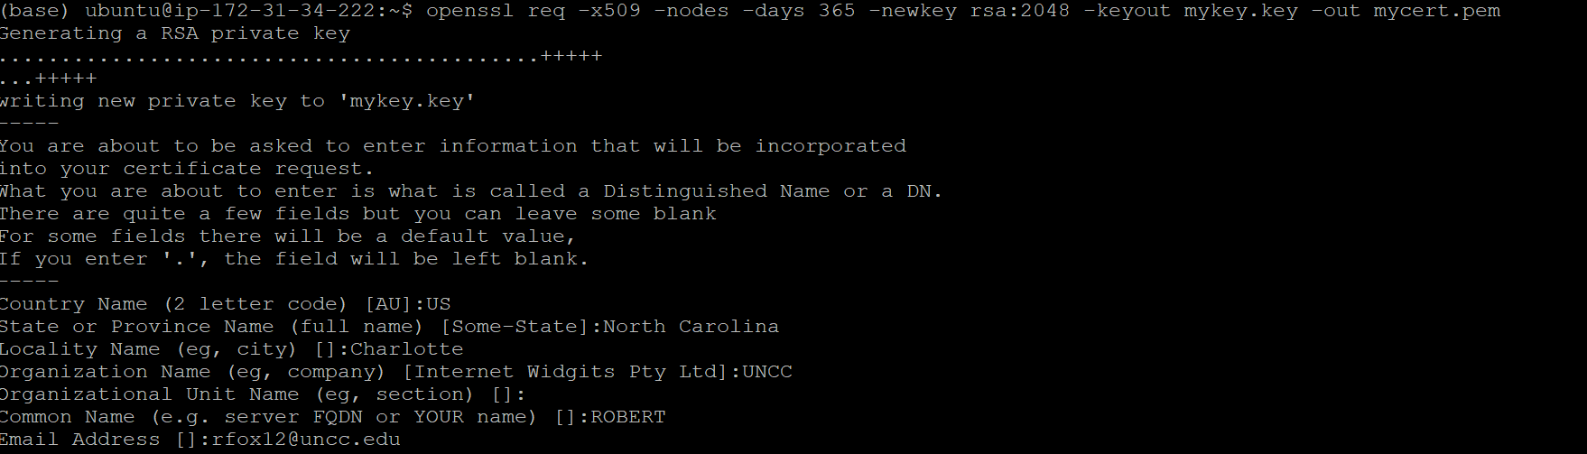
- If you’re handy with command line editors, you need to edit jupyter_notebook_config.py
- Follow the directions here to edit the file, ensuring you have port 8888 specified (instead of port 9999) https://jupyter-notebook.readthedocs.io/en/stable/public_server.html#running-a-public-notebook-server
- Now we need to go back to the AWS Management Console to open port 8888
- We need to find the “Security Groups” area
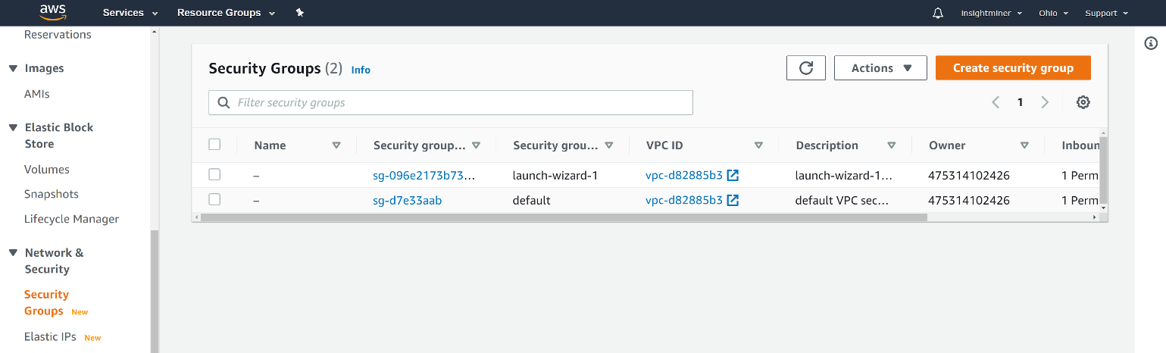
- Click “Create security group”
- Basic details:
- Name: “Jupyter”
- Description: “Opens port 8888 for Jupyter Notebooks”
- VPC (leave to default)
- Inbound Rules. We will add 2 rules.
- Rule 1: SSH, Source: Anywhere, then hit “Add Rule”
- Rule 2: Custom TCP, Port Range: 8888, Source: Anywhere
- 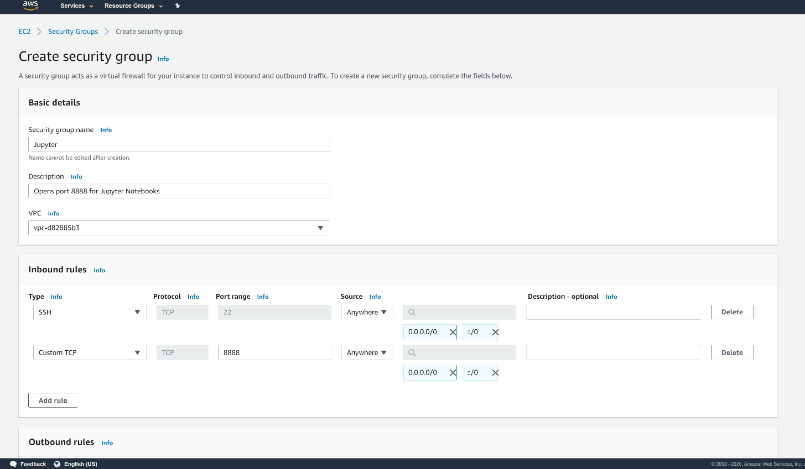At the bottom of the page hit “Create Security Group”
- Now we need to go back to our EC2 cloud instance on the AWS Management Console. You can find it under “Running Instances”. We’re going to change the security group to be the new one we just created. You can right-click or go into Actions and select “Networking / Change Security Groups”
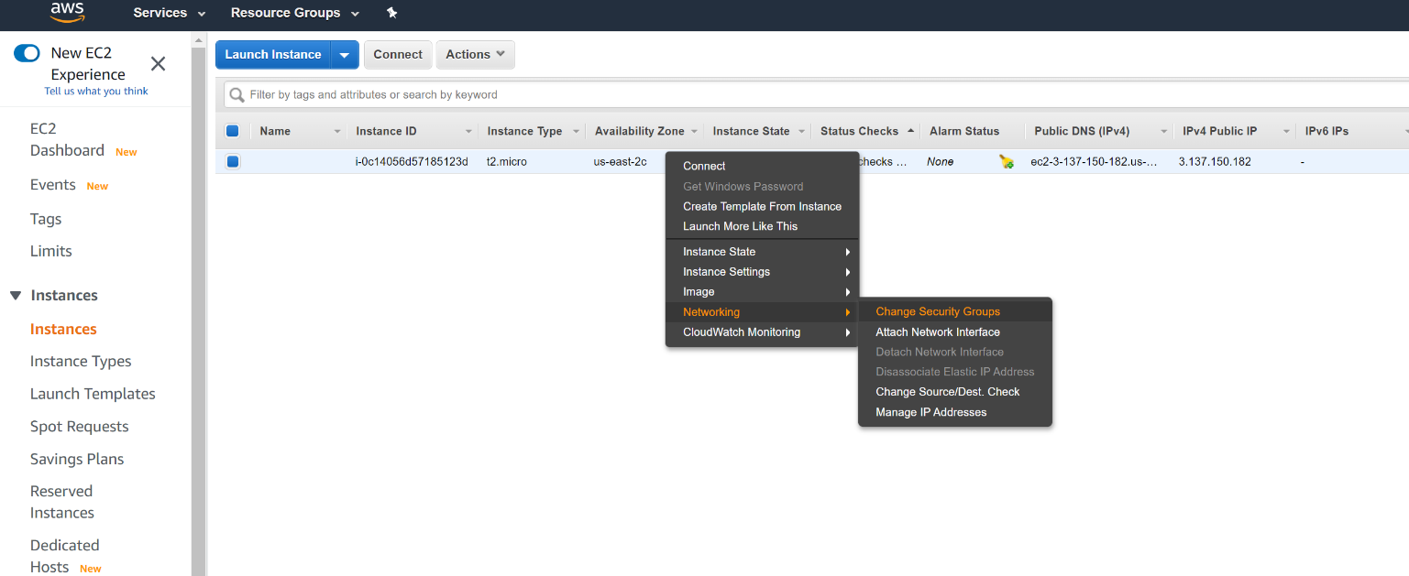

- Finally back in the command line, run “jupyter notebook”
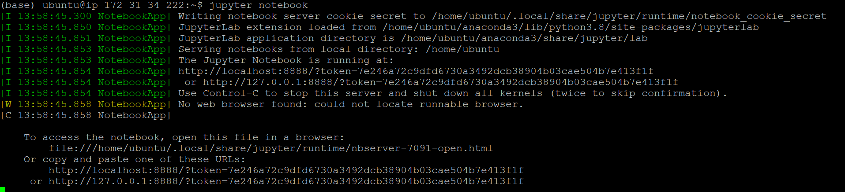
- Now we need to change the URL to something we can paste on our local machine browser. In this example, we replace “localhost” with the machine name we see in our instance “Connect” screen:
  - http://localhost:8888/?token=7e246a72c9dfd6730a...
  - http://ec2-3-137-150-182.us-east-2.compute.amazonaws.com:8888/?token=7e246a72c9dfd6730a...
- If this is successful, you should see the Jupyter environment in your browser pull up!
- For solution 2, ignore steps 1-13 above. This will be much easier. We’re going to tunnel HTTP traffic through our existing SSH connection on port 22
  - Type “jupyter notebook” on your Instance command line, output should be like step 12 above.
  - Go to your “Connect” screen for your Instance, and find your SSH command. Remember: even Windows users can use SSH if you use Powershell!
  - My example as shown on my “Connect” screen [don’t type this in]:
ssh -i "dbsa-6190.pem" ubuntu@ec2-3-137-150-182.us-east-2.compute.amazonaws.com
  - We’re going to modify this command line to make it a tunnel command line:
ssh -i "dbsa-6190.pem" -NL 8888:localhost:8888 ubuntu@ec2-3-137-150-182.us-east-2.compute.amazonaws.com
  - This tunnel will make it appear that your Jupyter notebook server is running on your local machine, so you can use the original URL that Jupyter recommends….
- Open the link provided when you executed “jupyter notebook” (somtething like http://localhost:8888/?token=7e246a72c9dfd6730a...)

Analysis with Jupyter Notebook:
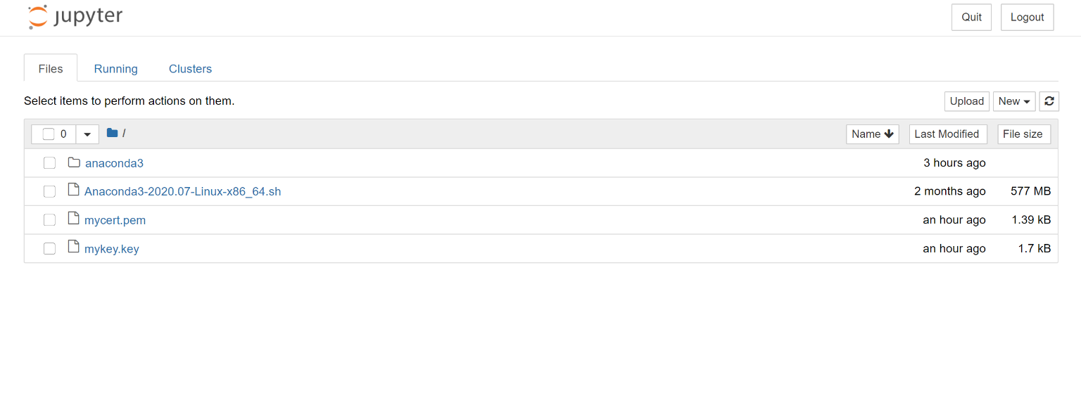
- Take the dbsa6190_intro.ipynb file from Canvas and use Jupyter’s “Upload” button to upload it to our cloud instance.
- Once it’s uploaded, open it.
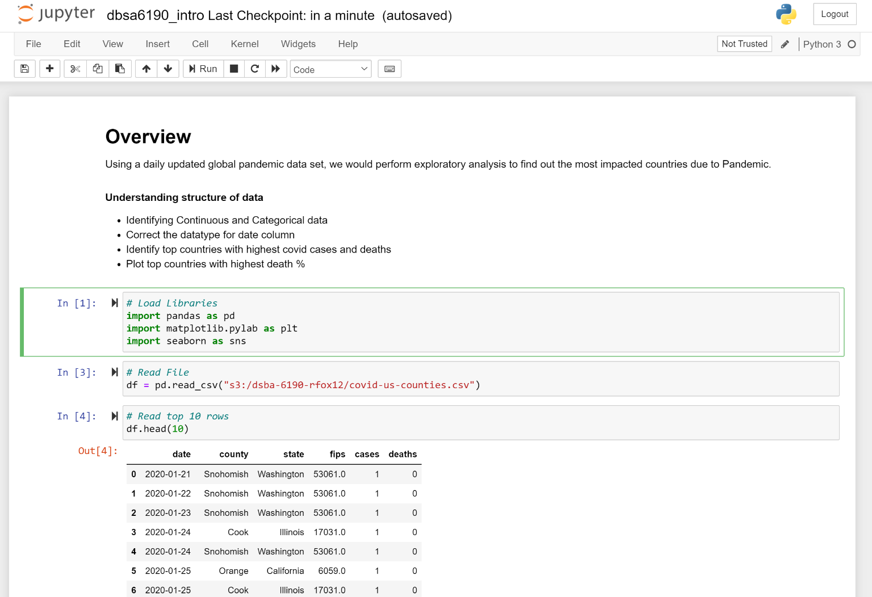
- The second cell must be changed to reflect your bucket name.
- Run all cells
- Print the page to PDF file, and submit to Canvas.

You can “Quit” in the Jupyter notebook environment; and that may stop the Jupyter server, but it won’t stop your EC2 cloud instance.

Always remember to Stop the EC2 Instance when you’re done (avoid being charged for compute time that you’re not using).
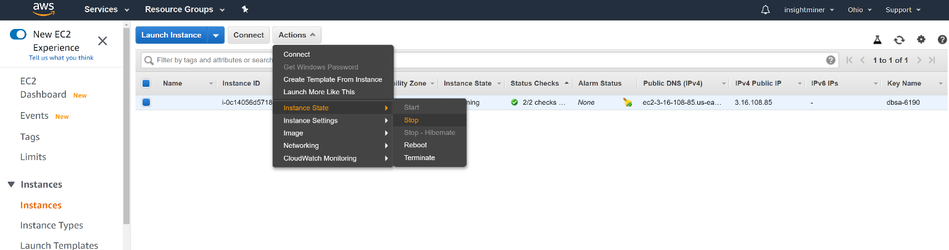

This screen confirms that my cloud instance is stopped:

